Chapter 8
The Seventh Seal—the Four Trumpets
- When the Lamb broke the seventh seal, there was silence in heaven for about half an hour.
This is the first time where it is recorded that there was silence in heaven, which signifies the magnitude of what was about to unfold. From chapter 4 till this point in chapter 8 there has always been praise given, but now, silence for half an hour (note: is there time in heaven? How is this half hour being measured?). Remember that the seventh seal (which proceeded the six seal) contains the seven trumpets so these events had not yet taken place. This is the second of the three seven events (seven seals, seven trumpets, and seven bowls).
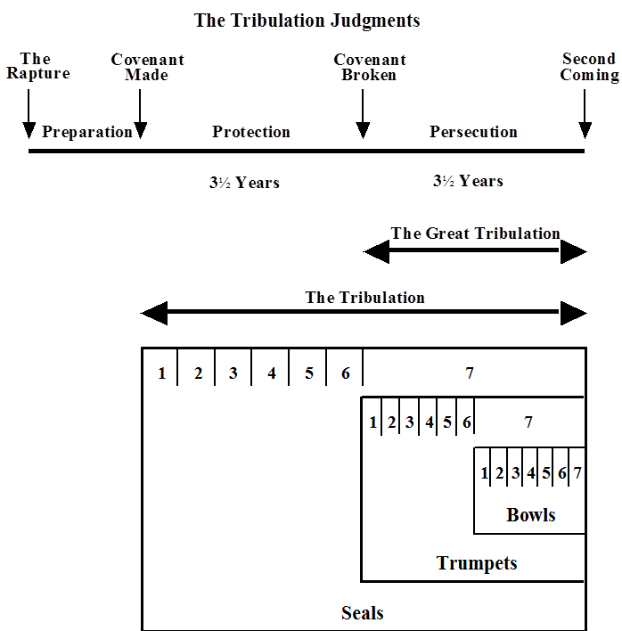

- And I saw the seven angels who stand before God, and seven trumpets were given to them.

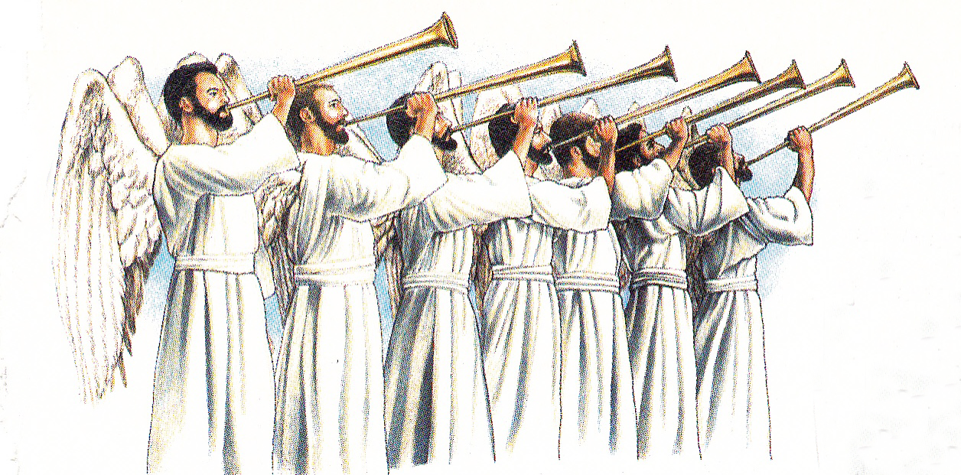

According to Walvoord (1995), the fact that John saw seven angels with the trumpets is a clear indication that these trumpets are not the same as the trumpet of God (1 Cor. 15:52; 1 Thes. 4:16) and from other New Testament trumpets (Heb. 12:19; Rev. 1:10; 4:1).

1 Corinthians 15:50 – 53

50. Now I say this, brethren, that flesh and blood cannot inherit the kingdom of God; nor does the perishable inherit the imperishable. 51. Behold, I tell you a mystery; we will not all sleep, but we will all be changed, 52. in a moment, in the twinkling of an eye, at the last trumpet; for the trumpet will sound, and the dead will be raised imperishable, and we will be changed. 53. For this perishable must put on the imperishable, and this mortal must put on immortality.

1 Thessalonians 4:16

14. For if we believe that Jesus died and rose again, even so God will bring with Him those who have fallen asleep in Jesus. 15. For this we say to you by the word of the Lord, that we who are alive and remain until the coming of the Lord, will not precede those who have fallen asleep. 16. For the Lord Himself will descend from heaven with a shout, with the voice of the archangel and with the trumpet of God, and the dead in Christ will rise first. 17. Then we who are alive and remain will be caught up together with them in the clouds to meet the Lord in the air, and so we shall always be with the Lord. 18. Therefore comfort one another with these words.

Revelation 1:10

I was in the Spirit on the Lord’s Day, and I heard behind me a loud voice like the sound of a trumpet,

Revelation 4:1

After these things I looked, and behold, a door standing open in heaven, and the first voice which I had heard, like the sound of a trumpet speaking with me, said, “Come up here, and I will show you what must take place after these things.”

- Another angel came and stood at the altar, holding a golden censer; and much incense was given to him, so that he might add it to the prayers of all the saints on the golden altar which was before the throne. 4. And the smoke of the incense, with the prayers of the saints, went up before God out of the angel’s hand. 5. Then the angel took the censer and filled it with the fire of the altar, and threw it to the earth; and there followed peals of thunder and sounds and flashes of lightning and an earthquake.

Another angel now appears in addition to the seven holding trumpets. This angel appears to be the announcer of the seven angels with the trumpets. He is standing before a golden altar with a golden censer and much incense was given to him to be added to the prayers of all the saints on the golden altar which was before the throne of God. Remember chapter 5:8 “When He had taken the book, the four living creatures and the twenty-four elders fell down before the Lamb, each one holding a harp and golden bowls full of incense, which are the prayers of the saints.”

The Tabernacle censer in the Old Testament was made with cooper and used to carry coals from the Brazen Altar outside of the tabernacle to the altar of incense on the inside; this was not the case during Solomon’s reign as king, for when the temple was built there were made golden censers for the temple (1 Kings 7:50; 2 Chron. 4:22). Note, this event follows the duties of the Levitical priest who would offer incense on the altar of incense in both the tabernacle and the temple. The priest would hold the censer in one hand with coals in it, with a separate vessel that carried the incense which was to be poured on the coals once the altar was reached. The resulting smoke was typical of prayer ascending before God. Here we see that the angel took the “censer and filled it with the fire of the altar, and threw it to the earth; and there followed peals of thunder and sounds and flashes of lightning and an earthquake.
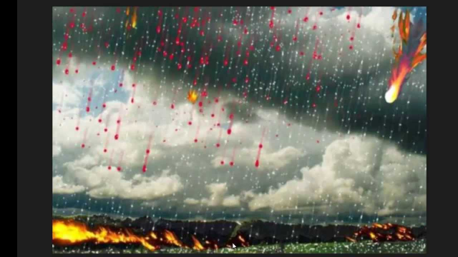

6. And the seven angels who had the seven trumpets prepared themselves to sound them. 7. The first sounded, and there came hail and fire, mixed with blood, and they were thrown to the earth; and a third of the earth was burned up, and a third of the trees were burned up, and all the green grass was burned up.
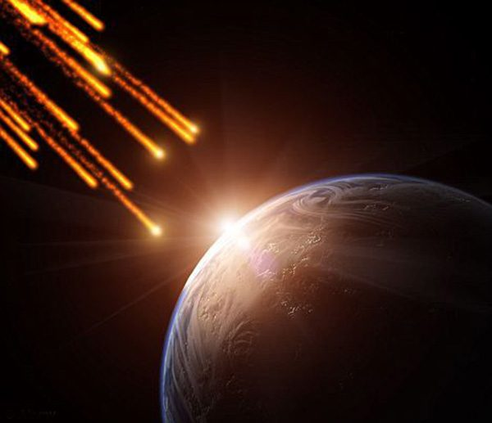
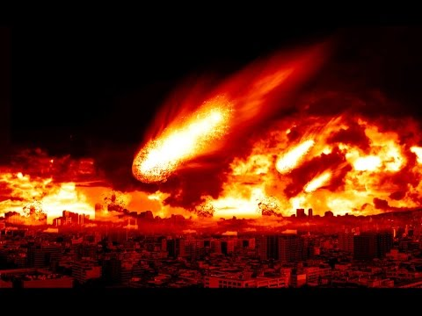
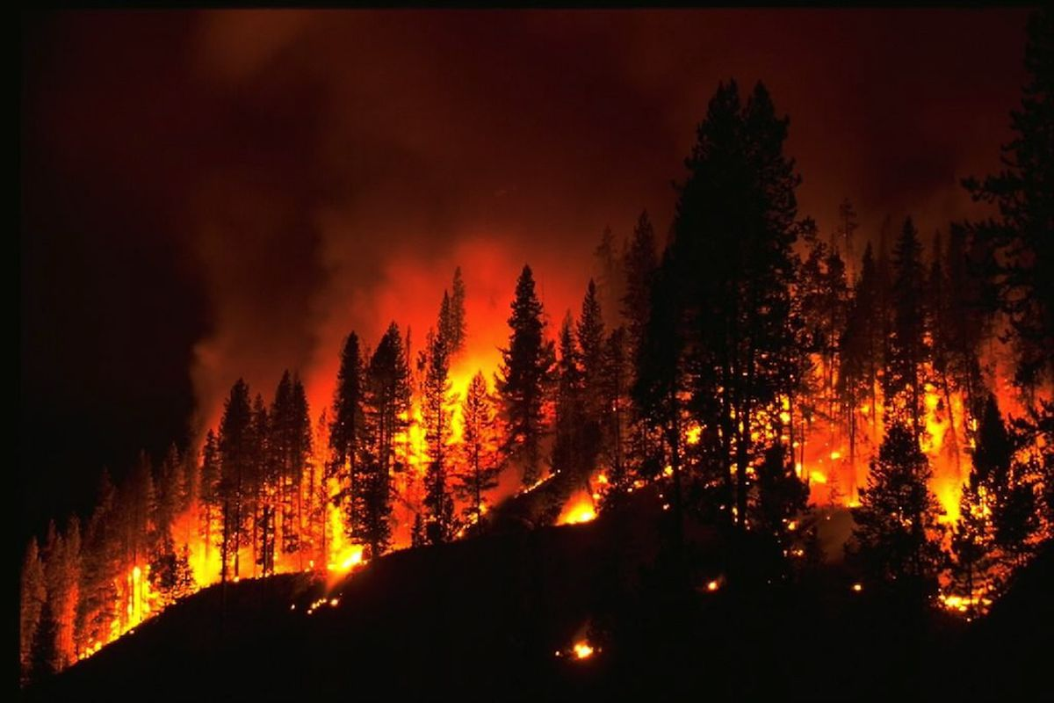
8. The second angel sounded, and something like a great mountain burning with fire was thrown into the sea; and a third of the sea became blood,

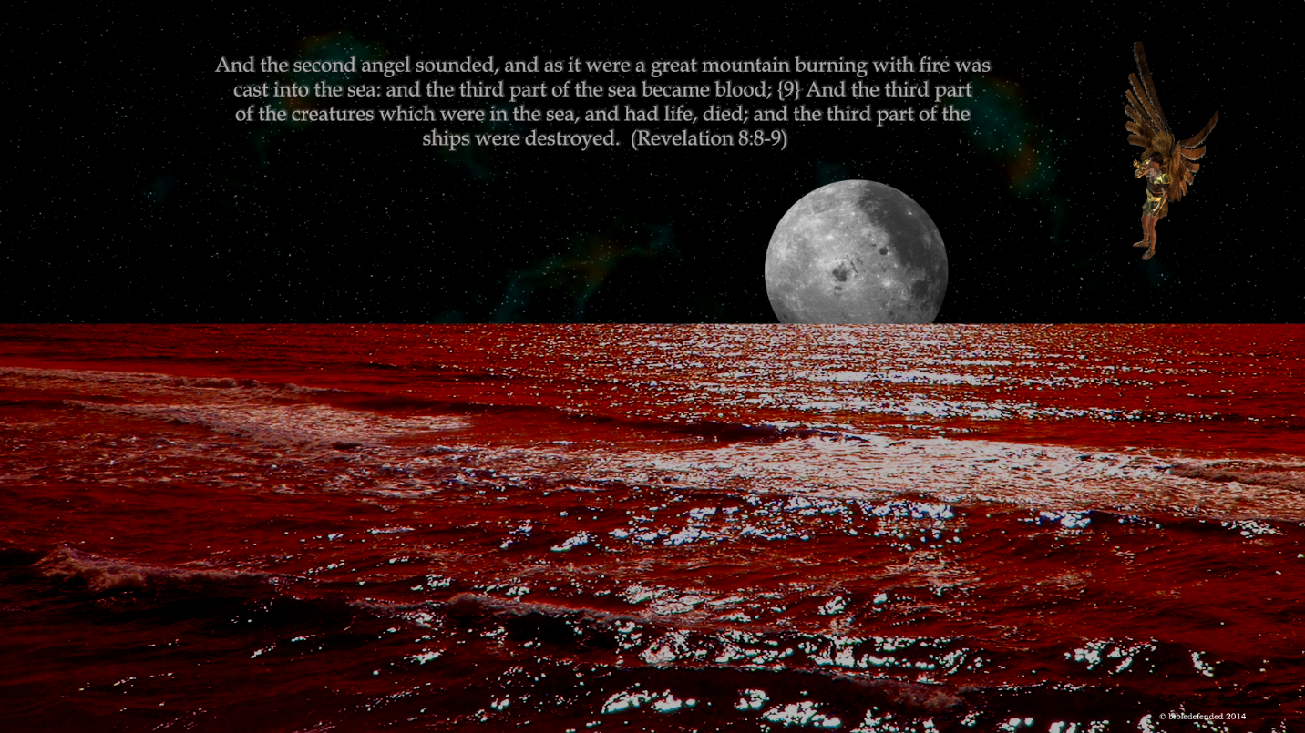

9. And a third of the creatures which were in the sea and had life, died; and a third of the ships were destroyed.
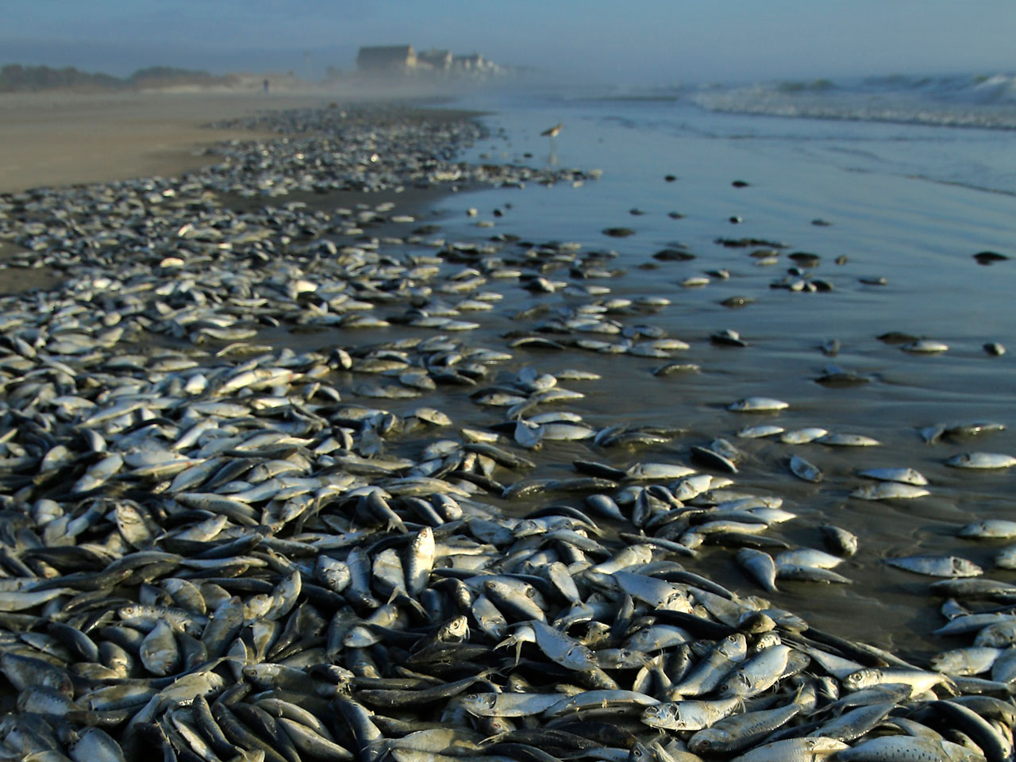
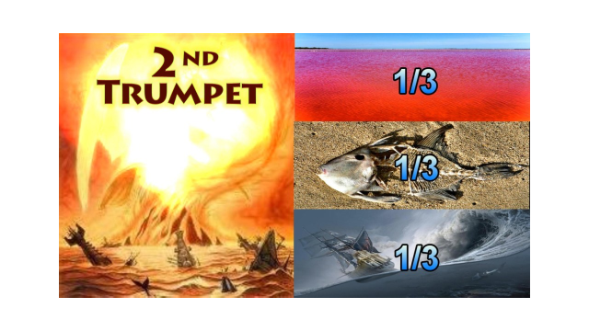
10. The third angel sounded, and a great star fell from heaven, burning like a torch, and it fell on a third of the rivers and on the springs of waters. 11. The name of the star is called Wormwood; and a third of the waters became wormwood, and many men died from the waters, because they were made bitter.

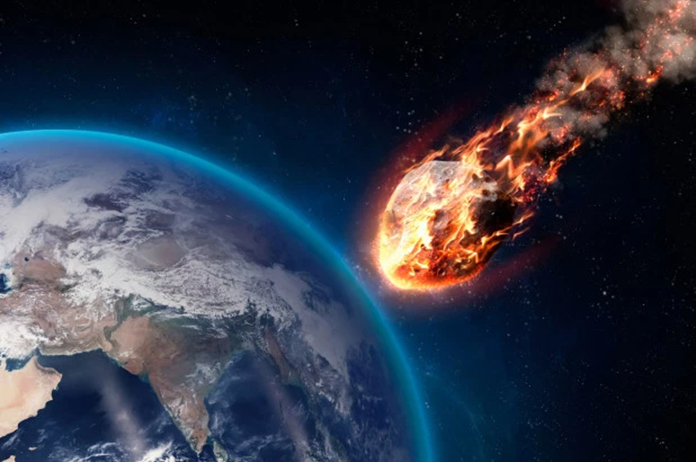

12. The fourth angel sounded, and a third of the sun and a third of the moon and a third of the stars were struck, so that a third of them would be darkened and the day would not shine for a third of it, and the night in the same way.
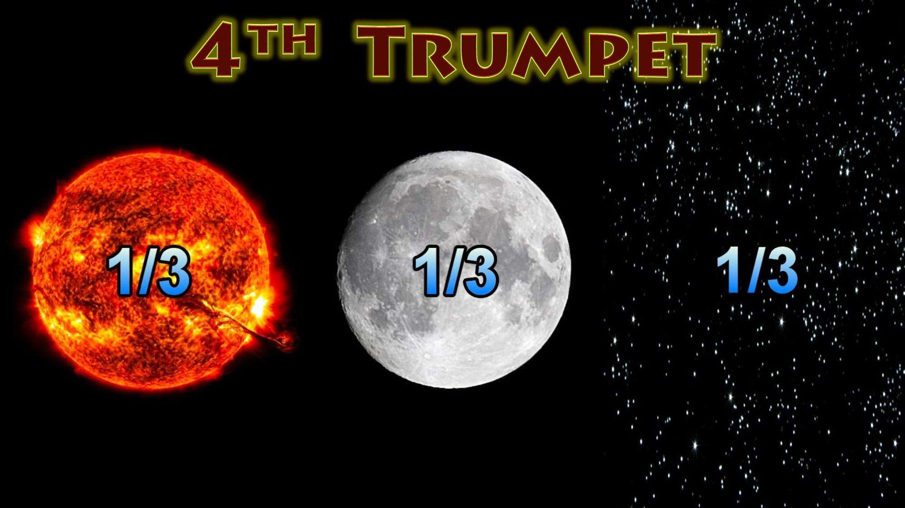
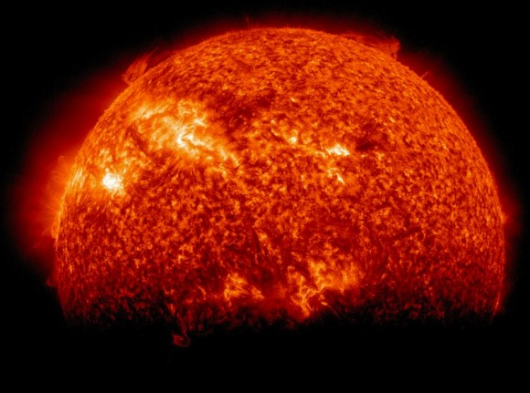

13. Then I looked, and I heard an eagle flying in midheaven, saying with a loud voice, “Woe, woe, woe to those who dwell on the earth, because of the remaining blasts of the trumpet of the three angels who are about to sound!”

Walvoord, J. F. (1985). Revelation. In J. F. Walvoord & R. B. Zuck (Eds.), The Bible Knowledge Commentary: An Exposition of the Scriptures (Vol. 2, p. 951). Wheaton, IL: Victor Books.

