chapter 2

Jesus’ Evaluation of Ministry: Message to the Seven Churches

Where is the Love: A Message to the Church at Smyrna
Revelation 2:1-7
No matter your race, culture, economic status, politics, educational background we all have a common problem. This problem does not discriminate, as a matter of fact, it visits everyone at some point and no one escapes it. It is the problem of suffering. Suffering is not a topic people like to discuss. Even though we all know that this life is temporal and everyone will someday encounter adverse pain we still cling to its vices in rejection of the reality of suffering. The Christian faith is the only religion that gives a reason and a hope in the midst of suffering and the ultimate outcome of it.

Today we are going to see God’s response to the suffering we encounter as His church. It is very difficult to understand the ways of God. But there is something about going through a difficult situation that draws God’s children closer to Him. What if God allows your affliction for His glory? What if it is His desire to see you grow in Him and the only way this would happen is by the very affliction you pray to be removed?

John 9:3 (NASB95)

3. Jesus answered, “It was neither that this man sinned, nor his parents; but it was so that the works of God might be displayed in him.”

This message today has two main factors, a four-point evaluation, and a two-step application; but let us first look at the historical background of the church at Smyrna.

Historical Background

SMYRNA (Smẽrʹ nȧ) was a large and wealthy city 35 miles north of Ephesus and like Ephesus, it was also a seaport. It had good harbor facilities, was at the end of a major road, and was surrounded by rich farmland. In contrast to Ephesus, which today is a deserted ruin, Smyrna is still a major city the modern city of Izmir, Turkey with a present population of about 2, 500,603 million (2018) and Turkey’s third largest city.
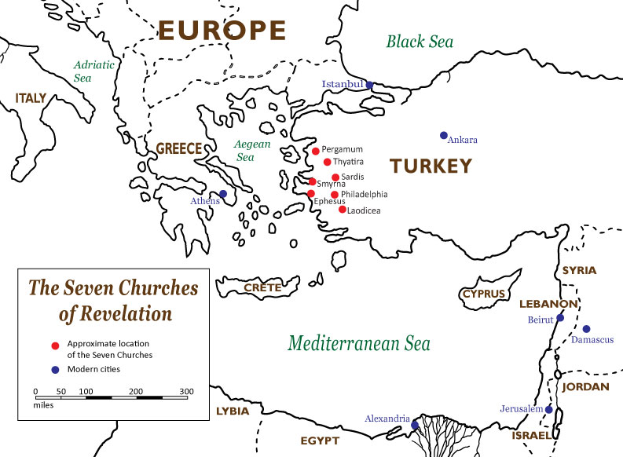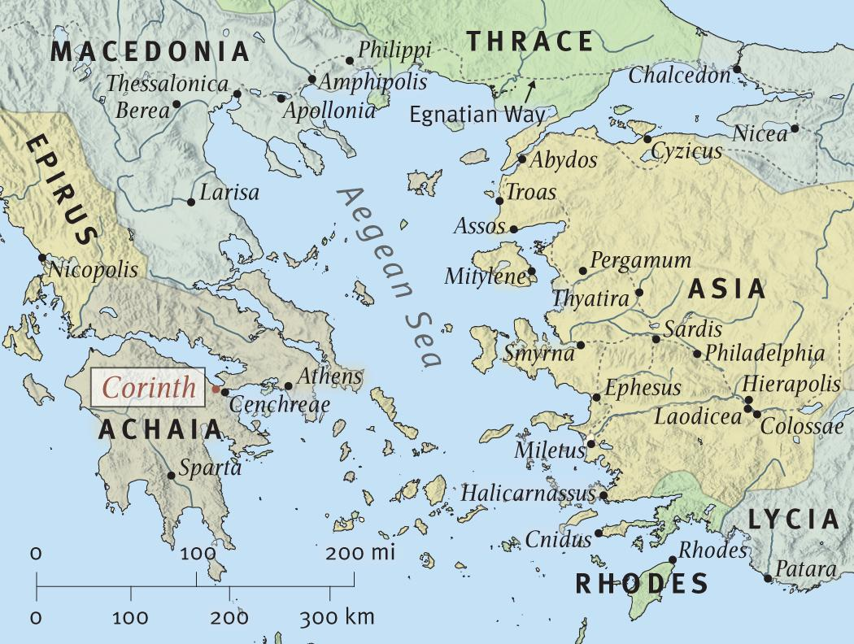
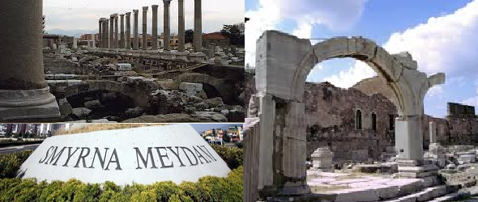

Smyrna means "myrrh," an ordinary perfume. It was used in the anointing oil of the tabernacle, and in embalming dead bodies. While the Christians of the church at Smyrna were experiencing the bitterness of suffering, their faithful testimony was like myrrh or sweet perfume to God.

This is the only place where Smyrna is mentioned in scripture, but the historical data shows that it was called ‘the glory of Asia’. This large flourishing commercial center was known for its wickedness and opposition to the gospel in the first century. This is where the letter was sent, to a small church in the midst of a large metropolis that was known to be antichristian.

Two main factor; please note that the two main factors are based on the evaluator’s credentials and His evaluation process

2:8 shows us the (1st factor) the identity of the Evaluator
2:9–11 shows us (2nd factor) His evaluation process

Factor (1). THE EVALUATOR:

8 “And to the angel of the church in Smyrna write”

Once again the evaluation process starts by addressing the “_______________” (angel) of the church and quickly moves into the identity of the ________________.

“The first and the last, who was dead, and has come to life, says this:”

Why is this description of Jesus so important? Christ reveals Himself as the eternal One who suffered death at the hands of His persecutors and then was resurrected from the grave. This description of Christ was especially relevant to the Christians at Smyrna who, like Christ in His death, were experiencing severe persecution.

Pay close attention to the ___________________ in identification.

It is very important that we do not miss how Christ introduced Himself in chapter one.

Remember in chapter 1:17-18 … He said “Do not be afraid; I am the first and the last, and the living One; and I was dead, and behold, I am alive forevermore,

He identifies Himself in chapter 2:8 as: “The first and the last, who was dead, and has come to life,

In this evaluation process, the evaluator is key

Factor (2). THE EVALUATION:

The second factor we find now is a four-point evaluation process.

STEP (A): Identifies the Condition/Situation of the church
Note how Jesus first acknowledges and empathize with the situation.

9 ‘I know your tribulation and your poverty (but you are rich), and the blasphemy by those who say they are Jews and are not, but are a synagogue of Satan.

I KNOW

This is a critical truth and demonstrates that Christ knows what we are going through, but notice He does not interfere with the process.

TRIBULATION – Generally refers to the suffering and anguish of the people of God and is the expected reality among the followers of Christ. It is the Greek word thlipsis which conveys the idea of “severe constriction,” “narrowing,” or “pressing together”.

Three truths as it relates to the tribulation of believers.

First truth: the tribulations of Christ are the pattern for the _______________ of ______________.

33 “These things I have spoken to you, so that in Me you may have peace. In the world you have tribulation, but take courage; I have overcome the world.” (John 16:33)

…strengthening the souls of the disciples, encouraging them to continue in the faith, and saying, “Through many tribulations we must enter the kingdom of God” (Acts 14:22).

For indeed when we were with you, we kept telling you in advance that we were going to suffer affliction; and so it came to pass, as you know. (1 Thessalonians 3:4).

Second truth: the tribulations of believers are in a sense participation in the ___________ of Christ.

Now I rejoice in my sufferings for your sake, and in my flesh I do my share on behalf of His body, which is the church, in filling up what is lacking in Christ’s afflictions. (Colossians 1:24).

For just as the sufferings of Christ are ours in abundance, so also our comfort is abundant through Christ. But if we are afflicted, it is for your comfort and salvation; or if we are comforted, it is for your comfort, which is effective in the patient enduring of the same sufferings which we also suffer. (2 Corinthians 1:5–6).

Third truth: the tribulations of believers promote transformation into the _____________ of Christ and teach believers to comfort and encourage others in similar situations, enabling those suffering to persevere and persist

And not only this, but we also exult in our tribulations, knowing that tribulation brings about perseverance; (Romans 5:3).

You also became imitators of us and of the Lord, having received the word in much tribulation with the joy of the Holy Spirit, (1 Thessalonians 1:6).

Your Poverty

This church was in the midst of a vibrant city, but its congregants were suffering in poverty. This is not a metaphor as the church at Smyrna was a poor church. Jesus did not take them out of their poverty. Instead, He told them to endure.

Blasphemy draws its Christian definition through the background of the OT. It is significant that blasphemy reflects improper action with regard to the use of God’s name. Blasphemy was a capital offense in the OT and required that the offender be stoned. Transliteration of a Greek word meaning literally “_________________.” In the biblical context blasphemy is an ______________ of disrespect that finds expression in an act directed against the ___________________ of God.

Blasphemy can be forgiven. However, blasphemy against the __________________ cannot be forgiven. This is a state of hardness in which one consciously and willfully resists God’s saving power and grace. It is a desperate condition that is beyond the situation of forgiveness because one is not able to recognize and repent of sin. Thus, one wanting to repent of blasphemy against the Spirit, cannot have committed the sin.

The synagogue of the NT era had its roots in the time after Solomon's temple was destroyed and the people of Judah went into Babylonian exile. Local worship and instruction became necessary. Even after Jews returned to Jerusalem and rebuilt the temple, places of local worship continued. By the first century, they were called synagogues.

Synagogue of Satan is to say that it was not a place where God’s ______________ was; nor were the people a ____________ of God. Like the anti-Christ, the synagogue of Satan is a ___________ seeking to make people believe that it is _______________.

STEP (B): Identifies the Coming Problem/Affliction

10 ‘Do not fear what you are about to suffer. Behold, the devil is about to cast some of you into prison, so that you will be tested, and you will have tribulation for ten days. Be faithful until death, and I will give you the crown of life.

“Do not fear what you are about to suffer.”
Note that there is no effort to take away the suffering. Instead, He encourages them to stay strong in the midst of it.
“Behold, the devil is about to cast some of you into prison, so that you will be tested, and you will have tribulation for ten days.”

Realize that before the devil shows up Jesus already knows his _____________. He did not bind or loose the devil, but rather _________________ the believer to stand.

Note the purpose of the devil is to ____________, and the outcome for the believer is tribulation.
But Jesus did not _____________ them, He simply encourages them. Why? Because the end result is the goal. The ______________, in Christ ______________.

STEP (C): Identifies the Action needed to be taken

11 ‘He who has an ear, let him hear what the Spirit says to the churches.
What is the Spirit saying to the churches? Join in the sufferings of Christ.

STEP (D): Identifies a Challenge to overcome

“He who overcomes will not be hurt by the second death.”

Revelation 20:6, 14
6. Blessed and holy is the one who has a part in the first resurrection; over these the second death has no power, but they will be priests of God and of Christ and will reign with Him for a thousand years.

14. Then death and Hades were thrown into the lake of fire. This is the second death, the lake of fire.

Revelation 21:8
“But for the cowardly and unbelieving and abominable and murderers and immoral persons and sorcerers and idolaters and all liars, their part will be in the lake that burns with fire and brimstone, which is the second death.”

Brand, C., Draper, C., England, A., Bond, S., Clendenen, E. R., & Butler, T. C. (Eds.). (2003). Smyrna. In Holman Illustrated Bible Dictionary (p. 1512). Nashville, TN: Holman Bible Publishers.
Information taken from http://worldpopulationreview.com/countries/turkey-population/cities/.
Walvoord, J. F. (1985). Revelation. In J. F. Walvoord & R. B. Zuck (Eds.), The Bible Knowledge Commentary: An Exposition of the Scriptures (Vol. 2, p. 934). Wheaton, IL: Victor Books.

